Wilson Basketball Cart
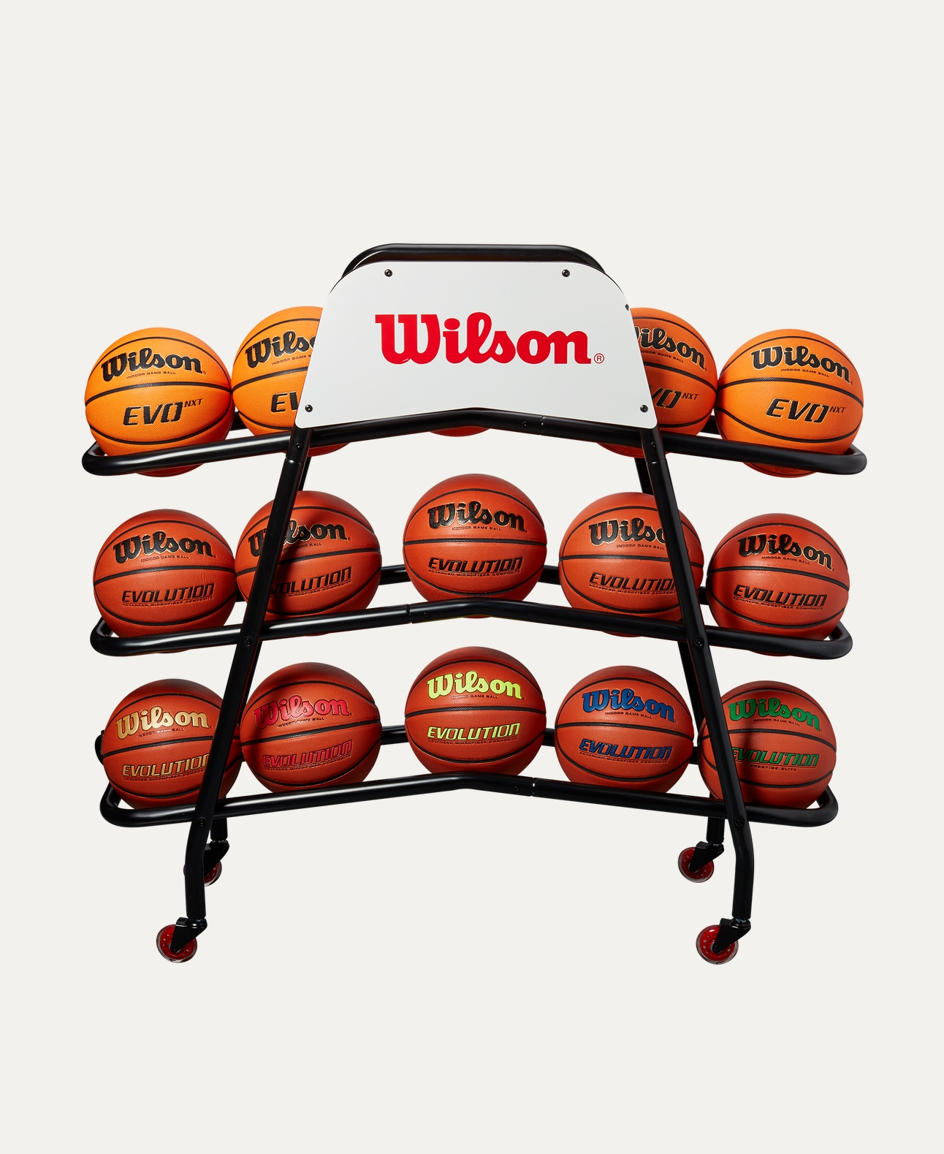
Price: Approximately Rs 25,999

Introduction
The Wilson Basketball Cart is a convenient and durable storage solution designed to organize and transport basketballs easily. Ideal for schools, academies, and sports facilities, it helps keep equipment neatly stored and readily accessible.

Product Overview
This Wilson Basketball Cart is built to hold multiple basketballs in one secure place. With a strong frame and smooth-rolling wheels, it allows effortless movement across courts and storage areas.

About the Brand
Wilson is a globally recognized sports brand known for high-quality sports equipment and accessories. Wilson carts are designed with the same focus on durability, functionality, and professional standards.

Key Features
- Holds multiple basketballs securely
- Smooth-rolling wheels for easy mobility
- Strong and stable frame construction
- Easy access open design
- Suitable for indoor and outdoor use

Design & Build Quality
The cart features a sturdy metal frame with a practical open-wire design, allowing quick loading and unloading of basketballs. Its stable structure prevents tipping during movement.

Storage & Capacity
Designed to store a large number of basketballs at once, making it ideal for team practices, training sessions, and tournaments.

Material & Durability
Made from high-quality steel or heavy-duty metal with a durable finish, the Wilson Basketball Cart is built to withstand regular use in sports environments.

Ideal For
- Schools and colleges
- Sports academies and clubs
- Coaches and trainers
- Indoor courts and gymnasiums

Care Instructions
- Wipe clean with a dry or damp cloth
- Avoid overloading beyond capacity
- Store in a dry place when not in use
- Check wheels periodically for smooth movement

Product Specifications
- Brand: Wilson
- Product Type: Basketball Cart
- Material: Steel / Heavy-duty metal
- Wheels: Yes (smooth-rolling)
- Capacity: Multiple basketballs
- Usage: Training & Equipment Storage

Product Summary
The Wilson Basketball Cart is a practical and reliable solution for organizing and transporting basketballs efficiently. Its durable construction and easy mobility make it an essential accessory for any professional or training basketball setup.

Thank you

